Basic commands In linux

/ -root
#-root user
$normal user

Commands syntax
$command opt arg

$pwd > present working directory
$cal > calendar
$cal –y >entire year
$cal -y 5 09 2026 > particular date
$cal --help > help
$cal –j >total days count till today

$echo > print out put

Variables -1.predefined , 2.user defined ,3.special variables
1.Predefined variables
$echo $HOME >user directory location
$echo $PATH >user directory location
$echo $0 / $SHELL >shell environment
$BASH_VERSION >print bash version

2.User defined variable
$Name=Mukesh
$echo $Name
0/p -> Mukesh
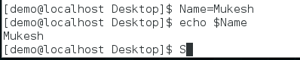
env - Predefined variable list

How can you switch user ?
su - root >su – switch user
su - user1
Q1 What is the difference between su - root / su - and su root ?
In su - root , it will swith into root with environment.means root user home directory will also switch.
Switches to the root user and creates a fresh login session as if root had logged in directly.
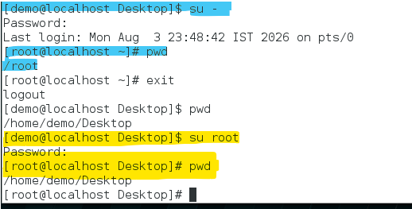
su root
Switches to the root user but keeps your current environment (current directory, many environment variables, PATH, etc.).
Q2What is the difference between sudo - root and sudo root ?
Q1 ans

$uname –a > kernel version

#date
$date > Tue Aug 4 00:05:00 IST 2026 (OS date and time)
$date +%T >00:05:11
$ date +%D >08/04/26
$date +%Y >2026
$date +%B >August

